Africa Catalyst
Phase 5

Applicant Guidance Notes

Deadline: Tuesday 28 November 2023, 1.00pm GMT

Contents

About Africa Catalyst 3
Programme objectives 3
Applying to Africa Catalyst 4
Scheme expectations 4
Eligibility criteria 6
UK partner matching………….…………………………………………………………………………………………………………7
Africa Catalyst phase five application and award timeline 8
Reporting timeline 10
D&I guidelines 11
Completing your application 13
How to apply 13
Assessment of applications 29

Any questions about this pack?

Please contact africaengineers@
raeng.org.uk

About Africa Catalyst

The Africa Catalyst programme was launched by the Royal Academy of Engineering in 2016 to support professional engineering bodies in sub-Saharan Africa to promote the profession, share best practice and increase local engineering capacity to help drive development.
Four phases of Africa Catalyst projects have been funded to date. Several projects have received multiple funding awards in order to continue to develop and disseminate their initiatives.
Cohort | Funding awarded | Length of project
Pilot | Up to £40,000 | Six months
Phase two | £30,000 to £300,000 | One to three years
Phase three | £70,000 to £160,000 | One to three years
Phase four | Up to £40,000 | Six months
Africa Catalyst projects have covered a rich mix of initiatives, ranging from student internships, graduate training schemes, the promotion, retention and upskilling of women in engineering, to STEM in primary and secondary schools, and the harmonisation and accreditation of engineering education and professional training.
The aim of phase five is twofold:
(a) To support new ‘pilot’ initiatives.
(b) To communicate, disseminate and exploit impact from successful projects from the pilot and phase two to four cohorts.

Programme objectives

To work in partnership with professional engineering and engineering training institutions to support strong engineering professional bodies in Africa.
1

A strong professional body is effective, self-sustaining, transparent and provides useful services to its members, as well as positively influencing public discourse on engineering. It has good governance, leadership, financial management, policies, and systems in place.
To identify how professional engineering bodies and training institutions can best promote the profession and better understand the current engineering landscape in the benefiting countries.
2
The Africa Catalyst phase five call awards grant funding of two size options, up to a maximum of £100,000 for one year. Africa Catalyst is supported by the UK government through the Department for Science, Innovation and Technology (DSIT).
Applicants should select one of the two grant size options and confirm their selection in the application form, as detailed below:

- Small grant: up to £50,000 for projects to be delivered over one year.
- Large grant: up to £100,000 for projects to be delivered over one year.

Applying to Africa Catalyst

Scheme expectations
This call is open to existing and new partnerships. In this round, reviewers are looking for either:
(a) New projects that aim to:
(I) strengthen the internal capacity of professional engineering bodies (PEBs)
(II) expand PEBs’ influence at both local and national level
(III) build up an engineering talent pipeline with the necessary skills to respond to local challenges.
(b) Projects that aim to communicate, disseminate and scale impact of successful projects from the pilot and phase two to four cohorts.
Up to £100k funding
Successful applications will also consider the following components:
- Sustainability of project outcomes beyond Africa Catalyst. Applicants must present a sustainability plan identifying the main stakeholders who will be engaged, their identified role and their impact on the project’s results.
- Diversity and inclusion (D&I) is a priority. Projects will ensure that the promotion of gender equality and equality for underrepresented groups is mainstreamed across all stages: ideation, implementation, and monitoring. We encourage applications that promote inclusive engineering ecosystems in sub-Saharan Africa.
- Innovative deployment of activities. Applications should seek to demonstrate innovative approaches and use technologies to build engineering capacity.

The Academy encourages applications that aim to support engineering policy research, policy creation and/or uptake. We would like to see projects that adopt a systematic approach to connect communities, networks and the media for the development of policy guidance documents, the delivery of sensitisation initiatives and the creation of evidence to influence policy. Please refer to question 2.5 of the application form for more details.

Successful applicants that plan to deliver policy-focused projects will receive tailored support from the Academy between January and September 2024, to encourage a practical, engineering systems lens to the analysis of complex challenges and policy solutions. More information about this will be provided to successful applicants at the contracting stage.
You can read about previous Africa Catalyst projects that have developed policy and promoted uptake in sub-Saharan Africa:
- Association of Professional Women Engineers of Nigeria (APWEN): promoting gender equality in the aviation, automotive and renewable energy sectors through the creation of the SheEngineer 30% Club.
- Makerere University, Uganda: incorporating resilience and sustainability requirements into infrastructure planning and policy.
- Institution of Engineers Rwanda: elevating the eco-system of the engineering sector in Rwanda.

Successful applicants are expected to participate in online and in-person Academy-led awardee workshops and embed learnings into project execution. Online workshops will be run between January 2024 and March 2024, and an in-person event in sub-Saharan Africa is expected to be organised in May 2024. Further details will be provided at the contracting stage.

Eligibility criteria

- Projects should clearly align with the programme’s objectives and expectations of this call as referenced on page 3 to 5 of these guidance notes.
- The lead applicant will represent and be a member of a not-for-profit engineering organisation based in one of the sub-Saharan African countries listed below*. The Academy encourages applicants from underrepresented backgrounds in engineering, including women.
- Projects should work in partnership with at least one UK-based organisation. UK partners should have relevant expertise to add value to the project outputs and outcomes. The Academy is interested in applications that reflect a structured and collaborative approach to incorporate the UK partner within the project.
- Projects are strongly encouraged to additionally collaborate with an in-country private sector partner to maximise impact.
- The Africa Catalyst programme is supported under the International Science Partnerships Fund (ISPF) and this call will fund only projects eligible for Overseas Development Assistance funding. Projects must meet the ODA eligibility criteria: to promote the welfare and economic development of a country or countries specified in this call; be designed to investigate and provide evidence of a specific challenge affecting a lower income country; and to efficiently address the identified development need. Applicants are expected to present a detailed plan for project activities and outputs, including sustainability plans for their project post funding.
- Projects should run between January 2024 and February 2025.
- Applications must be completed in English.
- Per-diem expenditure is not an eligible cost for this call.
- Applicants should select one of the two grant size options and confirm their selection in the application form, as detailed below:
- Small grant: up to £50,000 for projects to be delivered over one year.
- Large grant: up to £100,000 for projects to be delivered over one year.

*In line with eligibility criteria set by the UK government’s ISPF, lead applicant institutions must be from one of the countries listed below in order to be eligible to apply:
Angola; Benin; Burkina Faso; Burundi; Cape Verde; Central African Republic; Chad; Comoros; Democratic Republic of the Congo; Djibouti; Eritrea; The Gambia; Guinea; Guinea Bissau; Kenya; Liberia; Lesotho; Madagascar; Malawi; Mali; Mauritania; Mauritius; Mozambique; Niger; Réunion; Rwanda; Sao Tome and Principe; Senegal; Seychelles; Sierra Leone; Somalia; South Africa; South Sudan; Sudan; Tanzania; Togo; Uganda; Western Sahara and Zambia.
Institutions from ineligible countries within sub-Saharan Africa can still participate in projects as partners.

UK partner matching
To successfully apply for the Africa Catalyst phase five call, a UK partner must be formally involved with a written agreement in place.
If an applicant does not have connections or access to a UK partner, the Academy can facilitate this relationship. Please note that upon receipt of the partner request form, the applicant project details, and expertise request will be added to the partner matching form accessible on the Academy website. We will contact prospective applicants if there are any UK institutions showing interest and will connect the interested parties via email.

If you would like support in being connected with a UK partner, please fill out the partner matching form on the website on the ‘How to apply’ page by Tuesday 21 November 2023.

Any questions? The Academy will hold two information sessions on 31 October and 14 November 10.00am GMT to explain each section of the application form and answer any questions about the scheme. Find more information on the Academy website.

Please register your interest, indicating your preferred information session date, at africaengineers@raeng.org.uk

Africa Catalyst phase five application and award timeline

The deadline for applications is Tuesday 28 November 2023, 1.00PM GMT. Any incomplete applications or applications received after this date will not be considered.
Funds will be transferred according to the reporting and payments schedules defined by the Academy at the contracting stage. To avoid additional transfer charges, payments can be made directly to partners, if requested from the outset of the project. An indicative timeline can be found below:

- Upon completion of the initiation report in January 2024, awarded projects will receive a first payment of £60,000 (large grants) or £30,000 (small grants).
- Submission of progress report one, with no financial disbursement, will be made in May 2024.
- Upon successful submission of progress report two, a second payment of £30,000 (large grants) or £15,000 (small grants) will be made in October 2024.
- Upon project completion and successful submission of the final report, a final payment of £10,000 (large grants) or £5,000 (small grants) will be made in February 2025.
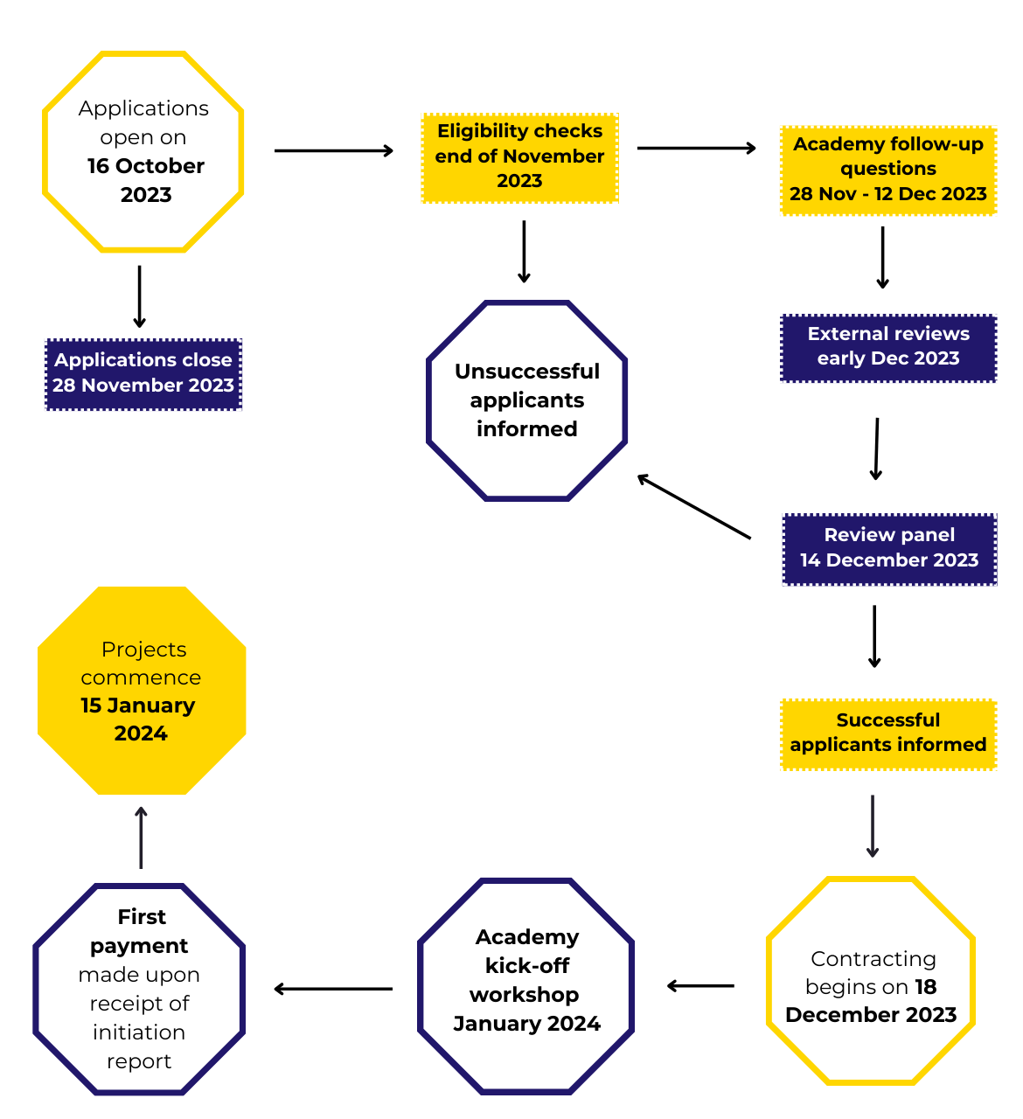
Africa Catalyst award timeline
Reporting timeline

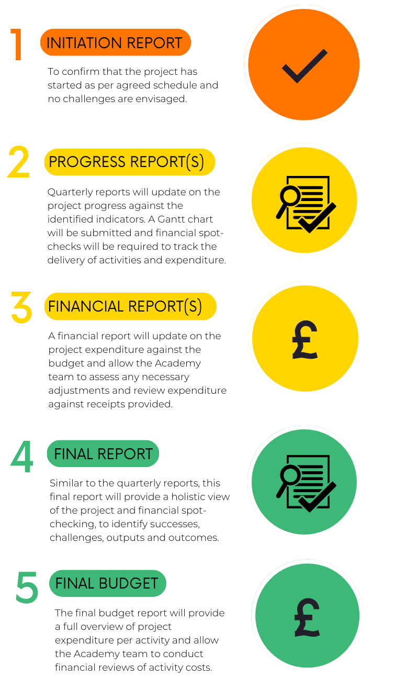
Close and frequent communication with the Academy is a requirement for all successful applicants. We encourage successful applicants to stay in regular contact with their dedicated project manager. The project manager must be informed of any changes to activities, timings, or the need to re-allocate funds over the course of the project.

In addition to regularly sharing relevant news about the project via email or meetings, successful applicants are expected to produce four reports during the duration of their Africa Catalyst grant.

In addition to regularly sharing relevant news about the project via email or meetings, successful applicants are expected to produce four reports during the duration of their Africa Catalyst grant, with the initial report confirming that the project has started on schedule. The three progress reports will be accompanied by an updated budget form and an updated Gantt chart.

Please note, if your grant application is successful, regular financial spot checks will be conducted as part of the reporting process. Please ensure you have proof of payment (i.e., receipts) for all expenditure. The Academy will not support any per diem expenditure.

D&I guidelines

The Royal Academy of Engineering strives to create cultures in which everyone can thrive, and we believe that diverse perspectives enrich our collective performance. In addition to being one of the Academy’s values, D&I is a critical part of the Academy’s strategy.

We know that underrepresented groups can be unintentionally excluded or overlooked unless specific attention is paid to their voices. Depending on the context, groups may be marginalised due to age, ethnicity, disability, gender and religion, and less visible differences such as sexual orientation, disability, socio-economic status, education background, personality type, and nationality, to name but a few examples.

This has a number of implications for this call:

We require you to ensure that your project design and monitoring and evaluation is informed by diverse voices and enables participation by an appropriately diverse group of stakeholders. Please see question(s) 3.10 and section 4 of the application form.
1

1

Why? We want to ensure that the planned activities, expected outputs and set outcomes are equitable and benefit underrepresented groups. This does not mean that your project needs to improve D&I directly. However, if you intend to create social impact, you should consider the different needs and interests of underrepresented groups who are part of the project target population or indirectly affected by the project activities and outcomes.

We encourage initiatives focused on addressing gender equality and the inclusion of underrepresented groups to build a sustainable society and an inclusive economy that works for everyone.
2

2

We expect projects to establish systems to gather diversity data and make an effective use of it to support D&I.
3

3

We encourage projects to embed at least one of the following D&I priorities for action* in their project goals to support gender equality and the inclusion of underrepresented groups:
4

Application and award process4

D&I priorities for action:

(a) D&I governance, strategy and planning
Putting systems, policies and practices in place to support progress on D&I.

(b) Establishing good governance
Ensuring systems of governance are in place to support progress on D&I, underpinned by active stakeholder engagement.

(c) Developing training and guidance
Building the capabilities of stakeholders (staff, members and other
stakeholders) through training and guidance on D&I.

(d) Targeted activities for specific demographics
Targeted activities for specific demographic groups, particularly in relation to
membership.

(e) Building external presence
Developing and enhancing external presence on D&I, particularly online and social media presence.

*D&I priorities for action are based on the D&IProgression Framework Report 2021 for professional engineering institutions, co-published by the Royal Academy of Engineering and the Science Council. You will find the report on the Academy website as part of the supporting documents for this call.
We will provide support and guidance to awardees on embedding D&I throughout their project cycle in the form of D&I awardee workshops between January and March 2024. Successful applicants will receive further details in due course.

Completing your application

How to apply

All applications must be submitted via the Academy’s online Grants Management System: https://grants.raeng.org.uk. Lead applicants must log onto the online system or create an account if they do not already have one. It is important that the application is started and completed by the lead applicant, who will be the main contact for the Academy should the application be successful.
The lead applicant can invite other contacts, for example the co-applicant or partner, to help complete the application form by creating a new account or logging into their Academy account. Please note that the user who starts the application will automatically appear as lead applicant, so please make sure roles are assigned correctly. Applications received that list a partner as the lead applicant will not be considered.
The application form has five sections and should take approximately 1 hour 30 minutes to complete, assuming questions have been answered offline and the applicant is copying and pasting in the information, rather than composing it from scratch. Applications must be completed in English.
These guidance notes give details of all the questions included in the application form. Please contact the team if you have any questions regarding the application process or online system at africaengineers@raeng.org.uk
Please note that applications will only be considered if the application is complete and all relevant documentation is submitted.

Once logged in, please select the scheme ‘Africa Catalyst Phase 5’ and you will be presented with the ‘Instructions’ screen.

Next you will see some general instructions about how to use the system as well as a list of the five sections of the application form:

- Applicant, organisation and partners’ details
- Project details
- Measuring progress and impact
- Finance
- Letter of intent and declaration
Please note that questions with an asterisk are mandatory. Additionally, if a question requires a certain file format (i.e., PDF), you will not be able to upload an alternative file type.
At any stage in the application process, you can save your progress and return to the application later. Questions may be answered in any order – it is possible to skip some sections and return to them later. We advise applicants to start the form and view the questions early on so that the requirements are well understood. Applicants should also ensure that they have all the necessary documentation at hand before completing and submitting the application.

Supporting documentation

As part of your application, you will need to submit:

- Registration documents
- Annual accounts
- Lead applicant organisational chart
- D&I policy (if applicable)
- Collaborating partners’ details
- Project Gantt Chart
- Project risk register
- Budget
- Letter of intent UK partner institution
- Declaration

Artificial intelligence (AI) guidelines for applicants

- Taking responsibility for content: applicants are fully responsible for all the content presented in their grant applications. The grant process does not penalise the use of generative AI tools, but it is imperative to ensure that the application reflects the applicant's own voice and ideas.
- Rigorous approach: applicants should exercise caution when using generative AI tools to avoid the inclusion of ‘hallucinated’ references or factual errors. These often become more common when up-to-date content on a very specific topic is required, which is typical for most of our application areas. Such inaccuracies will be perceived as indications of a lack of rigor and will negatively impact the assessment of the application.
- Partial use of AI tools: it is not acceptable to solely rely on generative AI tools to write the entire grant application from start to finish. While these tools may be used to assist in various aspects, the application must primarily represent the applicant's own work.
- Plagiarism considerations: applicants should be aware that the output generated by some AI tools may use ideas from other human authors without proper referencing. As this is considered a form of plagiarism, it is essential to ensure that all sources are appropriately attributed.

Please note that if the application is successful, monitoring reports will be checked against the documents submitted in this application, in particular those in the ‘Measuring progress and impact’ and ‘Finance’ sections. If reports do not conform with this or do not present enough and accurate information, they will be returned for resubmission.

Guidance on completing each section of the application form can be found below.

- Applicant, organisation and partners’ details

This section focuses on the lead applicant and lead organisation. The Academy will use this information to establish if your organisation is best placed to carry out the proposed project. The documents requested are necessary for due diligence purposes.

1.1 Lead and co-applicants contact details:
Please provide the name and contact details of the lead and co-applicants who will be involved in this project, including job title, email address, postal address and a telephone number. Your details will automatically be populated using the data provided when you registered – please check that they are complete and up to date.

The Academy requires a second contact person, who will be responsible for the project when or if the lead applicant is unavailable. You must add at least two contacts with a full name, contact type, complete address, phone number and email specified.

Please ensure the contact email address is correct and will be valid for the entirety of the application process as this will be the main method of communication regarding the outcome of the application.

1.2 Lead organisation:
This is the organisation represented by the lead applicant. Please state your organisation name, complete address, phone number and email.

1.3 Website:
This is the website of the lead organisation.

1.4 Date your organisation was established:
The date the lead organisation was set up. This may not necessarily be the registration date – rather, it will be the date that the organisation came into existence.

1.5 If you are a registered body, please upload your registration documents:
This is not compulsory, but they are helpful for due diligence and may add weight to your application.

1.6 Date of current financial year end:
State the last day of your fiscal year: for example, 31 March in the UK.

1.7 Provide the figures for your organisation’s most recent full financial year:
This question is asking about income and expenditure in your latest closed accounts. Please convert your currency to pound sterling (GBP).

1.8 Please upload your latest annual accounts:
This should be the latest closed accounts, depending on when your last fiscal year ended.

1.9 Staffing: how many people work for your organisation?
This question is asking about the full-time equivalent (FTE) of your paid staff and volunteers. For example, if you have two staff members working for your organisation part time at half of the usual working week, they would count as one FTE. Unpaid interns should be included in the ‘volunteers’ section.

1.10 Please upload an organisational chart:
This can be uploaded in any format, so long as it shows all current positions within your organisation. It should indicate whether each position is paid or voluntary.

1.11 If your organisation has a D&I policy (or similar), please upload this here:
We do not expect that all applicants will have a policy on diversity, equality or inclusion, but if you do, this will be considered favourably. The reviewers will look to see evidence of how D&I will be integrated into the project – you will be asked to address this in Section 2 (‘Project details’).

1.12 What is the vision and mission of your organisation? (200 words max)
Use this question to describe what your organisation does and what it was set up to achieve.

1.13 What is your organisation’s experience, relevant to this project? (500 words max)
Please describe any previous projects or activities that your organisation has participated in that are relevant to the proposed project, including how successful they were and when they were carried out. If staff who will be working on the project have other relevant experience, please also mention this.

1.14 How will your organisation’s capacity be strengthened as a result of this project? (300 words max)
Details on specific project outputs and activities will be asked for in the ‘Project details’ section and should not be included here. In this question, the reviewers would like to understand how the project will positively enhance the capacity of the lead organisation; and what long-term changes will result from the project.

1.15 Collaborating partners’ details: (400 words max)
Please outline who you will be partnering with and what their relevant experience is.

Please note that at least one UK partner should be involved in the project, but there is no limit to how many partners a project can have. Other international and regional partners involvement is not mandatory, but it is encouraged where there is clear value added.

1.16 Roles and responsibilities of your chosen partners: (400 words max)
It is important that there is a clear understanding on who does what. Please tell us about the proposed roles and responsibilities of UK, as well as any in-country and international partners.
For example, some partners may have a very hands-on consultancy role to help project manage or develop good governance practices. Other partners may donate their time to the project in the form of advice and guidance. Consider how much budget is allocated to each partner and how each partner will contribute to project activities.

1.17 If you are going to be partnering with a UK commercial/industry organisation as part of your project, please provide details on the nature of this collaboration (200 words max):
If a UK commercial or industry partner will be collaborating, the Academy needs to know more about the nature of the collaboration and whether that collaborator will be looking to receive funds as part of this grant. If such a collaboration is proposed, we will need to know how much and what the funds will be used for.
If the nature of the collaboration is akin to that of a service provider, for example funds are allocated to pay market price to a UK industry or commercial partner for a service that they could receive elsewhere (e.g. consultancy, access to certain tools) etc… then this would not be considered as providing a specific benefit. However, if the funds would be for something else, i.e. if the UK industry or commercial collaborator stands to receive a commercial benefit, and/or if they are going to receive beneficial rights to the IP that is generated on the project, i.e. getting ownership over the IP that is not balanced to what was contributed towards its generation, then subsidy control rules apply.
In such a case, the Academy could offer the grant under the Minimal Financial Assistance route - enterprises are allowed to receive £315,000 over three financial years under this route. In such cases the UK industry/commercial organisation would need to keep track of the funds received under this route and ensure they declared them when applying for other funding of this nature. The Academy is required to confirm the value of funds that UK partners have already received via this route prior to issuing the grant. This will involve some additional checks and paperwork on both sides.

1.18 Involvement in other Academy programmes (600 words max):
Please include any current Academy application, award or project that you or your partnering institutions are involved in or have been involved in over the last three years.

- Project details

This section gives you the opportunity to provide details on your proposed project, including outcomes, activities, expected outputs, stakeholders and means of communication.

Starting with a holistic viewpoint, consider these concise steps for developing project components:

- Begin with the bigger picture:

- Define transformative project goals that encapsulate your envisioned impact.
- Break down these goals into specific, measurable objectives that directly contribute to realising the overarching project vision.

- Link objectives to tangible outputs:

- Identify concrete outputs stemming from each objective.
- Ensure a clear and direct alignment between outputs and their corresponding objectives.

- Design activities for output attainment:

- Chart out activities that pave the path to each output.
- Explain how activities play a decisive role in directly generating the intended outputs.

- Harmonise inputs with activities:

- Allocate essential resources, workforce, and expertise for your activities.
- Confirm that inputs align proportionately with the complexity of each activity.

- Integration of impact indicators:

- Define specific indicators for both outputs and objectives.
- Ensure these indicators fulfil SMART criteria: specific, measurable, achievable, relevant, and time bound.

2.1 Project title: (20 words max)
This should be as short as possible and understandable by a lay person, but also descriptive of the project.

2.2 Project keywords:
Please provide up to four keywords that best describe this project.
For example: gender equality, entrepreneurship, upskilling.

2.3 Project location(s): (100 words max)
If your project is focused in specific areas, please list them. If it is nationwide, please state the country. If you will work across countries, for example if you plan to invite organisations from other countries to attend workshops or conferences, please mention that here.

2.4.1 Project rationale: (300 words max)
What problem or need is the project trying to address? This should be a short statement or summary.
Problem description example:

At present, only a few local engineers work on large renewable energy projects, with government favouring multinational organisations that recruit expatriate managers, professional and technical workers. Despite having 700 registered energy and infrastructure engineers, the Engineers Registration Board has recorded only 390 in practice in 2023.

2.4.2 Project summary (300 words max):
Please include further details on your proposed project including:

- how the project meets the objectives of the Africa Catalyst programme
- planned activities or research that this proposal is based upon, if relevant
- which stakeholders will be engaged as part of the project design phase and throughout the project
- if relevant, any lessons learned from previous projects or activities.

2.5 If you plan to work with policy research, policy creation and/or intake, please indicate what type of challenge you are trying to address and what level of policy expertise you may need to create sustainable outputs and impact (200 words max):

2.6 Project outcomes (250 words max):
What final result/s are you trying to achieve? This is the purpose of the project, and it should be clear and brief. Where possible, please limit your response to one or three major overarching outcomes and ensure the outcomes are SMART (specific, measurable, achievable, relevant and time bound).

Please define the specific changes in behaviour and institutions that your project aims to achieve and how you plan to measure them. What transformative change do you anticipate in the lives of individuals resulting from your project?

Example:

(1) Increased number of energy and infrastructure engineers employed in large renewable energy projects.

(2) Support policies that demand use of local labour with energy and infrastructure formal-sector wages closer into line with earnings in the informal sector.

2.7 Project indicators (no word limit):
How will you assess progress against your outcomes? Please list all indicators that you plan to deliver under this project with their corresponding values.
Indicators are means of measuring progress towards achieving the expected results and demonstrate the impact of your project. These should be SMART. We would like to see indicators for each activity of your project, reflecting the changes you anticipate and the progress you aim to track. Indicators can be quantitative or qualitative, depending on the nature of the objectives that the indicator aims to measure.

Some types of indicators (e.g., number of organisations that sign internship agreements, number of times academic staff use resources etc.) will be meaningless if simple quantitative measures are used in isolation. These indicators will need to be supplemented by qualitative descriptions.

Whenever possible, we suggest using a balance of quantitative and qualitative indicators to better communicate the extent to which the project delivers results e.g., describing the number of people benefiting from the project and the nature of those benefits.

Example:

(1) Number of companies with improved local talent recruitment policies.
(2) Positive response from government representatives regarding energy and infrastructure engineering challenges.
(3) Number of engineers better equipped to be employed on large renewable energy projects.

Please note that data on indicators is required to be disaggregated by age, gender, disability, and ethnicity. This disaggregation will provide valuable insights into the differential impact of your project on various groups within the community.

Successful applicants will also be required to monitor against programme-level indicators that will be provided by the Academy before projects start. Further support and resources will be provided at the kick-off and monitoring and evaluation workshops from January 2024 to March 2024.

2.8 Project key anticipated outputs (500 words max):
What are the particular outputs needed to achieve the outcome/s of the project? Please specify outputs that are directly linked to the desired changes.
‘Project outputs’ refers to the short- and medium-term direct and quantifiable results that the project intends to deliver. There may be several outputs. Outputs need to be SMART: specific, measurable, achievable, relevant, and timebound.

Example:

(1) 150 energy and infrastructure engineers will receive training on management skills.
(2) Develop an evidence-based report on the challenges faced by energy and infrastructure engineers reaching 100 key industry and government stakeholders.
(3) 20 renewable energy companies will be exposed to the local talent gap, challenges, and opportunities in the country.
(4) 20 renewable energy companies will agree to adopt local talent responsible hiring policies.
(5) The Engineers Registration Board will gain representation in a government advisory board for strategic planning for climate change adaptation.

2.9 Project activities (1,000 words max):
Please list all activities you plan to deliver under this project. Please include a short description, associated values and participants.

‘Activities’ refers to the main tasks that need to be completed for the outputs to be achieved. There may be several for each output. Statements should be brief and include action words.

Activity examples related to output two (‘Develop an evidence-based report on the challenges faced by energy and infrastructure engineers’) included on question 2.8:

(1) Collect 400 survey responses from energy and infrastructure engineers regarding challenges faced in the sector.
(2) Publish one report on the challenges and opportunities for energy and infrastructure engineers in the relevant country.
(3) Organise a sensitisation conference to disseminate the results of the report.
(4) Hold five workshops with industry and government representatives for affirmative action towards increased employment of local talent.

2.10 How have you considered gender equality in the project or activity design? (400 words max):
In line with the UK government’s Gender Equality in Research and Innovation Policy, all successful applications to this scheme must demonstrate consideration of the activities on gender. All funded activities will, and at a minimum, ensure that no harm is done to gender equity. ​

To this end, please outline any specific gender considerations and implications for your proposed project. This could include any measures you have put in place to ensure equal opportunities, any expected impacts on people of different genders, or any outcomes or outputs that you will measure disaggregated by gender.​

Please read the D&I guidelines on pages 11 and 28 of the applicant guidance notes before answering this question.
Please note that progress on meeting gender goals should be tracked throughout the project life cycle and included on monitoring and evaluation processes.

2.11 How will you contribute to advancing D&I through your project? (250 words max):

To advance D&I through your project initiatives, consider your team, collaborators, communities the project works with, the implications for your project design and topic, and how you will measure success.
In your response, please ensure you also clearly explain and outline how you will measure the progress and inclusion of underrepresented groups against project objectives.

2.12 What platforms and communication channels will you use to deploy and implement your activities to raise the profile and the visibility of the project?
(200 words max)
Reviewers are keen to see:
1) how the lead organisation will communicate with the different partners and stakeholders involved in the project to achieve the objectives
2) innovative approaches and the use of technology in the projects. For example, which technologies would be used to share messages and expand reach? This may cover the use of social media, online platforms or other technologies.

2.13 What type of challenges do you foresee and how will you overcome them? (200 words max)
We appreciate that current circumstances can be challenging for project delivery, for example countries still affected by COVID-19 outbreaks, conflict and/or climate change-related crises. In this answer, we would like to see that you and your team have considered these circumstances when making project plans and can adapt if necessary.

2.14 ODA eligibility:
Please outline how your project fits the criteria for ODA funding.
The Africa Catalyst programme is supported under the ISPF and this call will fund only ODA-eligible projects. Projects must meet the ODA eligibility criteria: to promote the welfare and economic development of a country or countries specified in this call; be designed to investigate and provide evidence of a specific challenge affecting a lower income country; and to efficiently address the identified development need.

2.15 Please select the primary Sustainable Development Goal (SDG) that your project will address from the list below:
Please refer to page 22 of this guidance for more information on the 17 SDGs, or visit
www.un.org/sustainabledevelopment/sustainable-development-goals/

2.16 You may select a secondary SDGs that your project will address from the list below.

2.17 You may select a tertiary SDG that your project will address from the list below.

Project Gantt chart
Please upload a project Gantt chart, using the template provided by the Academy.​
A Gantt chart is a type of bar chart that lists each planned activity under the project and shows when they will take place. It can also be useful to add a column that states who will undertake the activity. The more detailed this is, the better.

Project risk register
Please upload a project risk register, using the template provided by the Academy.
A risk register is a living document, so will change during the project lifetime. It is, however, important that you submit a pre-project risk register that details the potential risks, their likelihood and possible consequences, as well as what will be done to mitigate the risks. A risk register is presented as a grid.

- Measuring progress and impact
This section is critical because it will provide a blueprint for both the Academy and lead applicant to measure progress and to demonstrate success and impact, detect project challenges and assess project sustainability.

3.1 Monitoring and evaluation
How will you and your partner(s) track progress against the project outcomes? Where will you find the relevant data and how often do you plan to collect it? What processes are in place to identify issues and mitigation strategies if activities are not going as planned? (600 words max)
What information will you need, who will be in charge of collecting it and how and from where can it be gathered?

3.2 Learning and adaptation
Please tell us how you are planning to embed lessons learned during the implementation of your project and after project completion, and with whom you plan to share those experiences. (200 words max)
Please describe how you will integrate lessons learned and whether you will share those lessons with anyone. If you will, please explain who they are and why you plan to share this information with them.

3.3 Project sustainability
Please tell us how you intend to sustain the project once the grant ends. (400 words max)
Which project activities do you foresee being able to continue or scale up after this grant ends? If funding is necessary for those activities, please describe how you plan to secure further funding. Please describe sustainability plans beyond funding.

A note on project sustainability
In order to be sustainable, a project must be:

- adaptable, to cope with a changing environment and unexpected circumstances
- realistic, feasible, attainable and implementable
- scalable, to expand its scope of operation or accommodate additional components of the project.

A key characteristic of project sustainability is project participation. Ownership of the project outcomes ensures the support and active involvement of project partners and stakeholders. Giving the target groups that the project aims to support an opportunity to take part in the decision-making process helps ensure that the objectives and activities, and monitoring processes, respond to the needs the project is trying to address.

4. Finance

Total grant funding requested (£):
Please note this should not exceed £100,000 and should be aligned to one of the two grant funding options listed in page 7 of the Applicant Guidance Notes.

Please convert your currency to pound sterling (GBP) using this online tool: www.xe.com/currencyconverter/

Budget
Please upload a budget, using the relevant template provided by the Academy.
The budget templates are split into ‘revenue costs’ and ‘capital costs’. While the Academy does fund capital costs, any such purchases should be justified and clearly needed for the project implementation.

Please note that the budget must be submitted to the Academy in pound sterling (GBP). Budget lines for bank charges and inflation can be included where necessary – please explain how these have been calculated in the ‘notes’ section.

It is important that your budget is activity based, meaning that each budget line should be broken down into as much detail as possible. Please add headings and additional rows as needed. For example, a heading such as ‘selection of participants’ could be broken down into stationery, venue hire, chair hire, with one row each.

It is important that your figures are realistic and based on real quotes. If you have a finance department, please ask them to check that your budget is realistic before submitting this. Where possible, including a document that demonstrates sign-off from the finance department will add weight to your application.

4.1 How have you considered value for money in your project design? (400 words max)
Value for money (VfM) is not always about getting the cheapest option, but about using resources well. It means finding the best balance between the four Es (economy, efficiency, effectiveness and equity) to ensure the quality of the project outcomes and to create value.
Please give an estimate of any in-kind support that the project will receive and outline what you have done to address value for money in your project proposal.

VALUE FOR MONEY AND THE FOUR Es EXPLAINED
Economy refers to the costs of the inputs needed for the project. For example, are project inputs (such as staff, technical expertise, etc) of the appropriate quality at the right price?
Efficiency refers to the costs of delivering the expected outputs (results). For example, how well are the inputs being converted into outputs?
Effectiveness refers to whether the project’s outputs translate into the project’s outcomes (objectives) and desired impact, and at what cost. For example, are the outputs produced by the project having the intended effect on the hub and its partners, and the project target groups?
Equity means assessing how fairly the benefits of a project are distributed and the extent to which those benefits reach excluded and underrepresented groups. For example, is the project benefiting some groups more than others? Are outputs reaching woman and girls? It is also important to consider what will happen if these groups are not reached. Are your project benefits available to and reach all people that they are need to?
The purpose of the VfM framework is to develop a better understanding of costs and results so that the project team can make more informed, evidence-based choices to determine what outputs and outcomes a project can realistically expect with the desired quality and at the lowest price.
These results are not just short-term tangibles but should also be longer-term sustainable benefits for the hub and its partners, and the target groups.

Please note, if your grant application is successful, regular financial spot checks will be conducted as part of the reporting process. With this in mind, all expenditure should be able to be receipted (proof of payment). The Academy will not support any per diem expenditure.

5. Letter of intent and declaration

5.1 Letter of intent UK partner institution
Please upload a letter of intent from the UK partner taking part in the project.
The UK partner letter of intent should include:
- confirmation of their commitment for the project
- outlining their role within the project
- how it fits within their strategic aims
- what form the support will take (staff time, guidance, facilities, facilitation, etc).

5.2 Declaration
This section asks the lead applicant to indicate that they understand that they will be required to sign a contract; confirm that the information stated in the application form is correct; that they agree to work with the Academy to mitigate fraud; and that they agree that the application will be shared with external assessors.
You can upload the statement found in this section as an additional scanned document if you wish.

I confirm here and by submitting this application that:

- all information is accurate at the time of submission
- the ideas presented are my own and not plagiarised or containing IP that is not owned by myself
- all contributions have been appropriately referenced or credited including the use of any online tools such as AI generative tools used in developing my application
- I understand that failure to cite and declare references or sources will result in my application being removed from the process
- I understand that my application and any content including IP shared within will be shared with reviewers as part of our application process
- I have the express permission of any individuals whose contact details I have shared as part of our application process, to share these details with the Royal Academy of Engineering.

Once your application is complete, a ‘submit application’ button will appear at the top of this page.

If you think you have completed the application, but the button has not appeared, please go back through and ensure every question is complete and that you have pressed save on every page. Likewise, any co-applicants who have edited this form must press save on every page before the button will become available.

Assessment of applications

Applicants will be evaluated by a specially chosen panel with expertise spanning the breadth of engineering, professional institutes and international development. Applicants may be required to answer follow-up questions based on the review. Applications should be understandable to the non-specialist engineer. Reviewers will allocate a numerical score to each application and give comments. All applications will be assessed against the following judging criteria:

- Has the awardee submitted all requested relevant documentation (Gantt chart, risk register, budget)?
- Does the proposal align with the objectives of the scheme?
- Does the organisation have suitable capacity and experience to carry out the project?
- Has the applicant included a suitable budget, within the financial parameters of the call, that links cost to the project activities outlined?
- Is the timeline realistic?
- Does the project demonstrate VfM?
- Does the proposed project meet ODA eligibility criteria?
- Are suggested activities achievable and sensible?
- Is it innovative in the approach and is technology used in an appropriate way?
- Quality of monitoring and evaluation plan – are the processes clear and appropriate?
- Sustainability – will it have lasting impact beyond the lifetime of the project?

Please note that the Academy will retain personal information as per our Data Retention Policy.

Gender equality statement

Question 2.8 and 2.9 of the application form refer to the inclusion of gender diversity and marginalised groups in the project design and implementation, as well as in the monitoring and evaluation plan.

This is a key question, and your project’s eligibility will be assessed against this. Please see the criteria below:

Fail = ask for more details

- Response is minimal or dismissive. No considerations are evident, or there is not enough information to demonstrate understanding of gender implications.
- Potentially negative implications have been ignored or are acknowledged but not mitigated for.
- The project is likely to exacerbate gender inequality.
- Note: If the response still receives a RED score after the applicant has had the chance to revise their statement, the application will fail eligibility checks and will not progress to review stage.

Pass = pass: specific gender equality benefits likely

- Evidence that gender implications have been well considered in the project design, and there is a clear pathway to a positive impact on gender equality.
- Where potential negative impacts are identified, efforts have been made to mitigate.
- Gender impacts will be measured, monitored and managed and clear evidence of active mitigation of any negative impacts.
- There may be reference to gender in monitoring, evaluation and learning plans, including KPIs, sex disaggregated data, or specific measurement of gender-related outcomes.
- There may be reference to stakeholder consultation with a gender lens.

During the eligibility check period (28 November to 1 December 2023) please be ready to answer questions on your gender equality statement as this is a key part of the eligibility process.

Still have questions?

Please contact africaengineers@raeng.org.uk

Frequently Asked Questions can be found on our website.
Start your application: https://grants.raeng.org.uk

