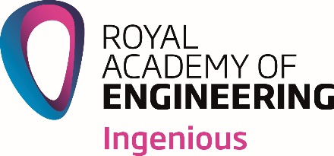

**Ingenious Public Engagement Awards**

**Interim Report Form**

The Royal Academy of Engineering’s *Ingenious* Public Engagement Awards support projects that:

* inspire creative public engagement with engineering projects
* motivate engineers to share their stories, passion and expertise with wider audiences and develop their communication and engagement skills
* raise awareness of the diversity, nature and impact of engineering among people of all ages and backgrounds
* provide opportunities for engineers to engage with members of the public from groups currently underrepresented in engineering.

Additional information is available from [www.raeng.org.uk/ingenious](http://www.raeng.org.uk/ingenious)

All enquiries should be directed to:

Marianne Jaskiewicz

Public Engagement Manager

The Royal Academy of Engineering

3 Carlton House Terrace

London

SW1Y 5DG

🕿 020 7766 0683

[marianne.jaskiewicz@raeng.org.uk](mailto:marianne.jaskiewicz@raeng.org.uk)

1. **Project details**

Principal applicant name:

Organisation:

Grant reference: ING  
Project title:  
Total Ingenious grant awarded: £  
Total Ingenious grant spent to date: £

1. **Progress report**

2a. Please confirm if your project is on schedule.

Yes: my project is on schedule  
 No: my project is not on schedule but I do not need to make any changes*

No: my project is not on schedule and I do need to make changes to my project*

*Changes can include project end date, location, or the activities to be undertaken and are approved at the discretion of the Public Engagement Manager.

2b. If you have indicated that you need to make changes to your project, or if you would like to inform the Public Engagement Manager of any other news regarding your project, please provide details below.

2c. Please confirm that the project is on budget

Yes – my project is on budget  
 No – I am not going to spend my full grant  
 No – I would like to re-allocate funds within budget lines

2d. If you have indicated that your project is not on budget, and/or you want to re-allocate funds, please give details below.

2e. Please confirm that your engineers have completed the pre-project questionnaire and you have returned them to the Public Engagement Manager

Yes: pre-project questionnaires have been completed and returned

No: pre-project questionnaires haven’t yet been returned

2f. If you haven’t yet returned the pre-project questionnaires, please provide a date below for when this will happen

2e. Have you used or shared any *This is Engineering* content during your project so far?

Yes

No

If no, do you intend to?

Yes  
 No